# Experiment No. 4

**Title:** Working in Codenvy to demonstrate Provisioning and Scaling of a website.

# Objective:

To learn Codenvy Platform as a Service (using Redhat Openshift Developer sandbox because now this service is Aquired by redhat openshift)

# Tools used:

Internet , Redhat Openshift Developer sandbox , Github

# Prerequisite:

Understanding of Platform as service model of cloud computing

**Theory:** Codenvy, now acquired by Red Hat and integrated into the Red Hat OpenShift platform, is a cloud-based integrated development environment (IDE) that provides developers with the necessary tools to code, build, test, and run applications. The platform is designed to simplify the development process by eliminating the need to install software and manage servers, thereby allowing developers to focus solely on writing code.

In this experiment, we are using Codenvy to demonstrate the provisioning and scaling of a website. Provisioning refers to the process of setting up IT infrastructure. It can also refer to the steps required to manage access to data and resources, and make them available to users and systems.

Scaling, on the other hand, is the ability of the system to handle and adapt to an increasing amount of work. In the context of a website, this could mean the ability to serve more users concurrently, handle more data, or run more complex applications.

Red Hat OpenShift is a family of containerization software products developed by Red Hat. Its flagship product is the OpenShift Container Platform—an on-premises platform as a service built around Docker containers orchestrated and managed by Kubernetes on a foundation of Red Hat Enterprise Linux.

# Steps:

**Step 1: Create Red hat account by visiting the Redhat’s website, click on login**

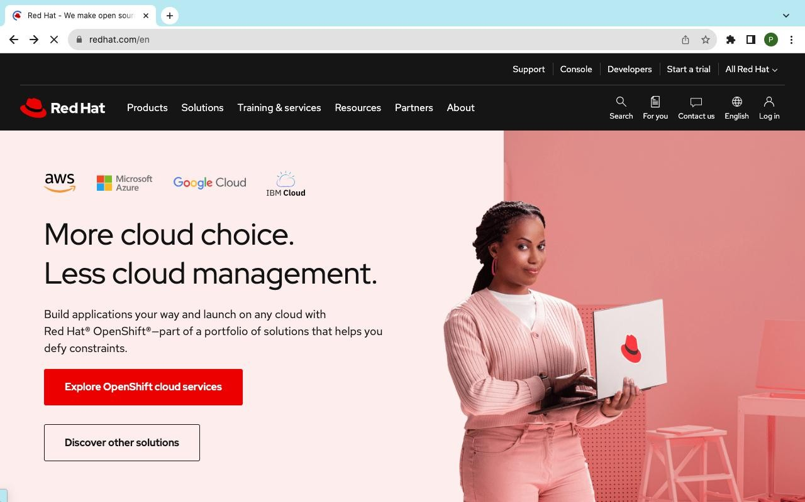

# Step 2: Click on register and fill the information and click on create my account

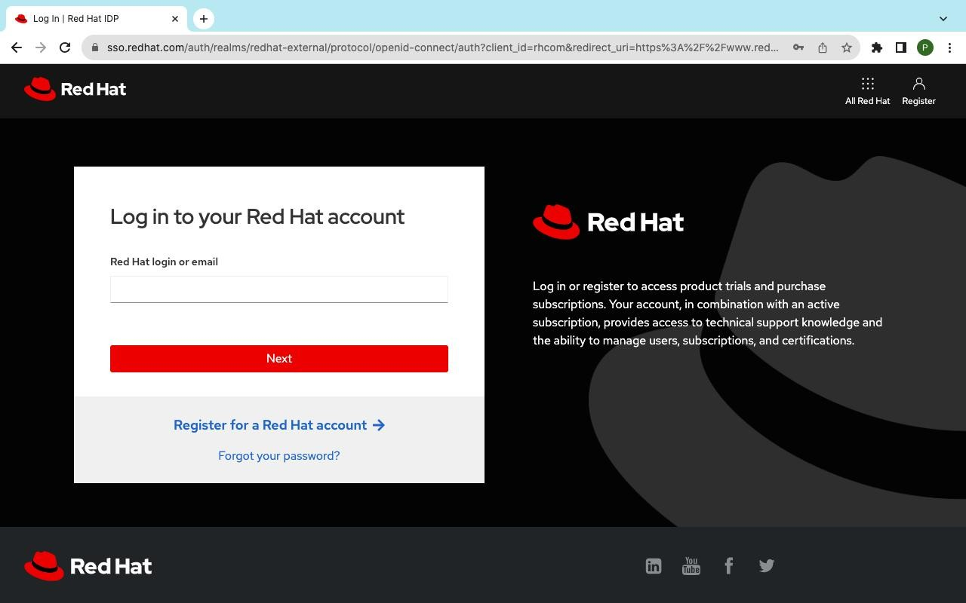

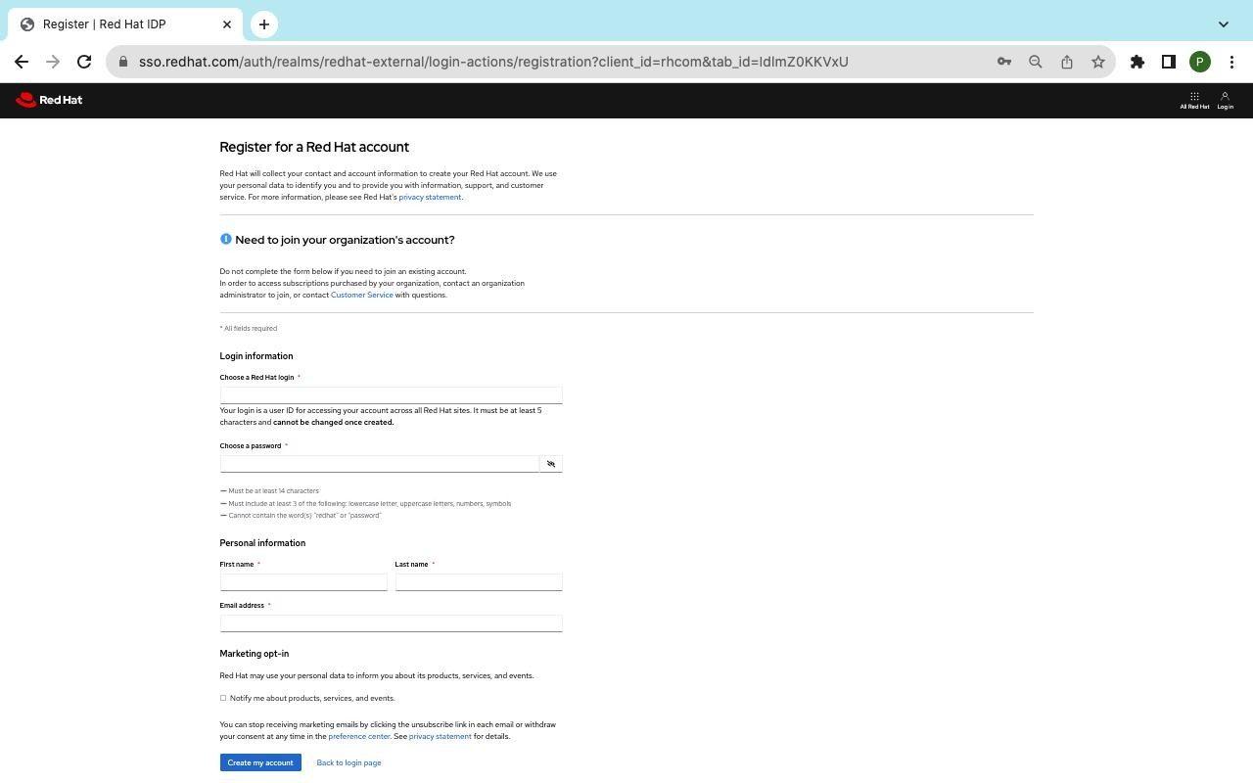

**Step 3: Verify your email address**

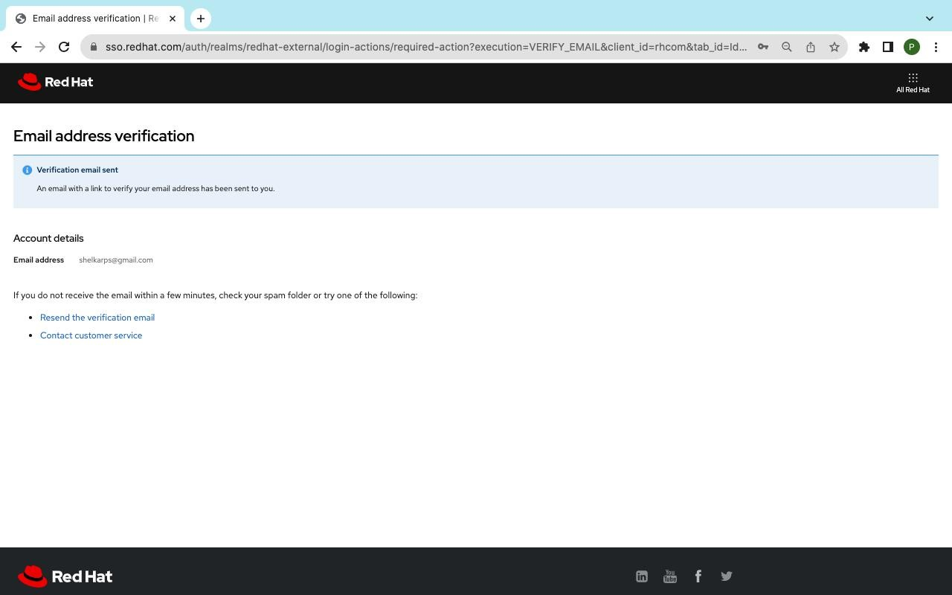

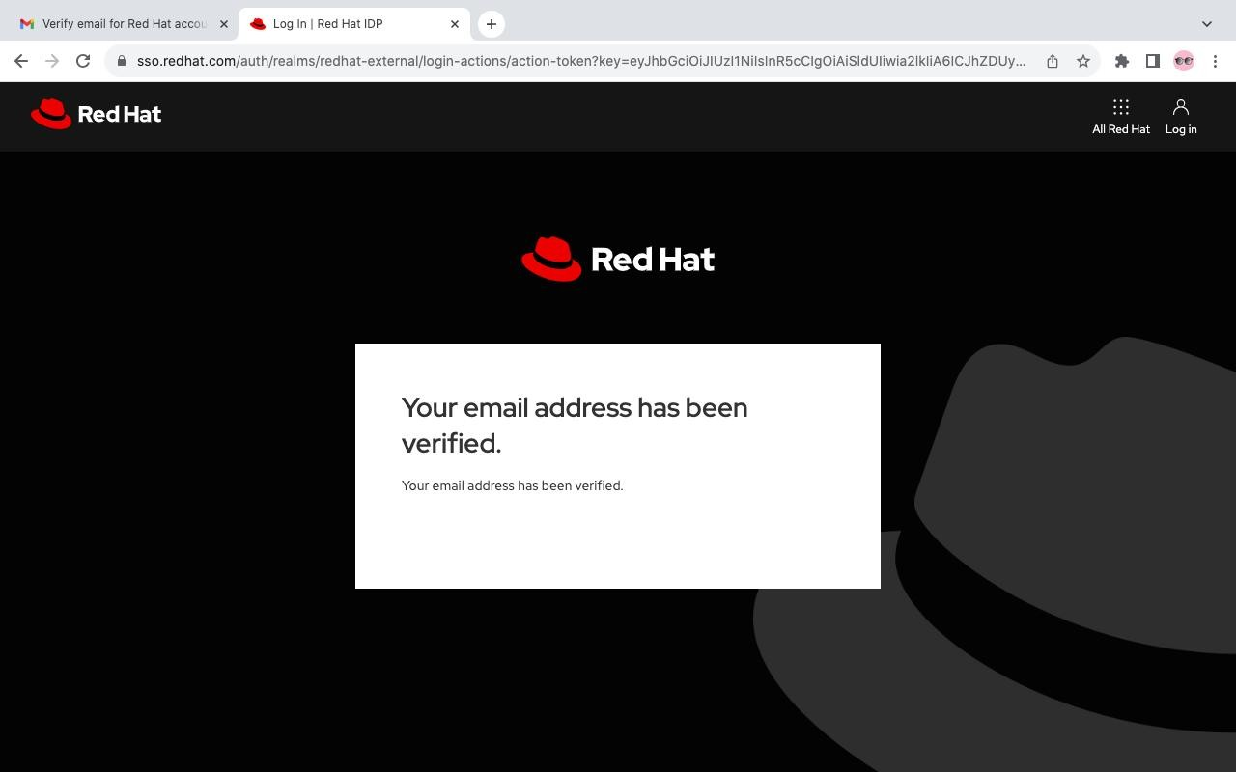

# Step 4: Again login and click on All Red Hat and then choose the third option Red hat Developer

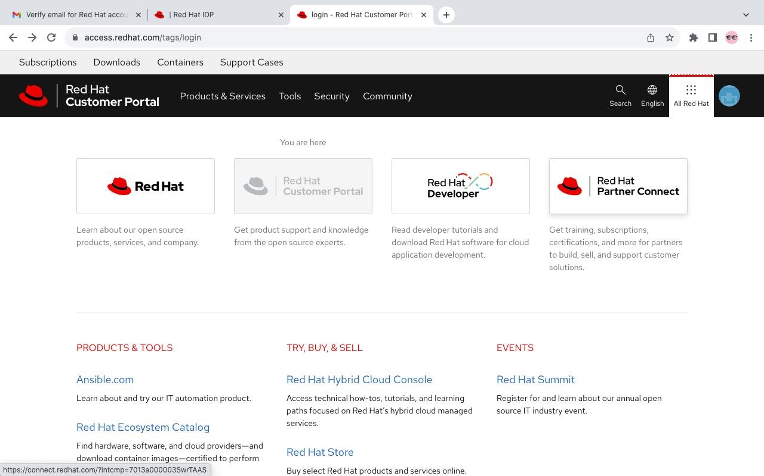

**Step 5: Click on Developer sandbox and then Explore the free Developer Sandbox**

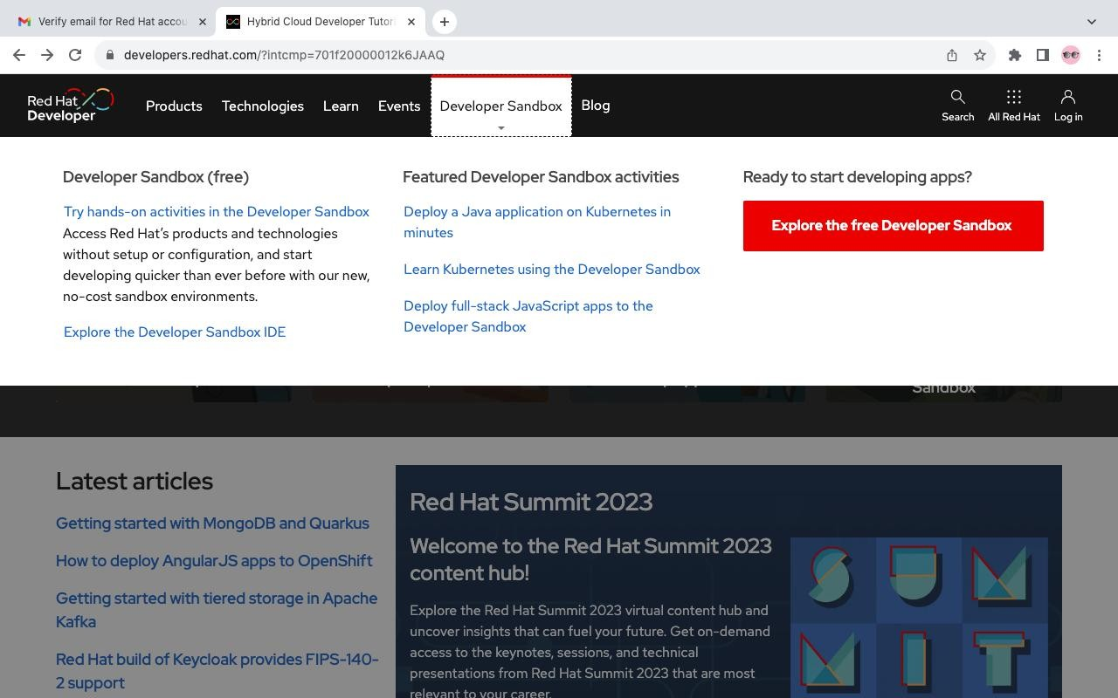

# Step 6: Scroll to bottom of the page and then scroll back to top of the page and click Start your sandbox for free and verify your account by entering the verification code if needed

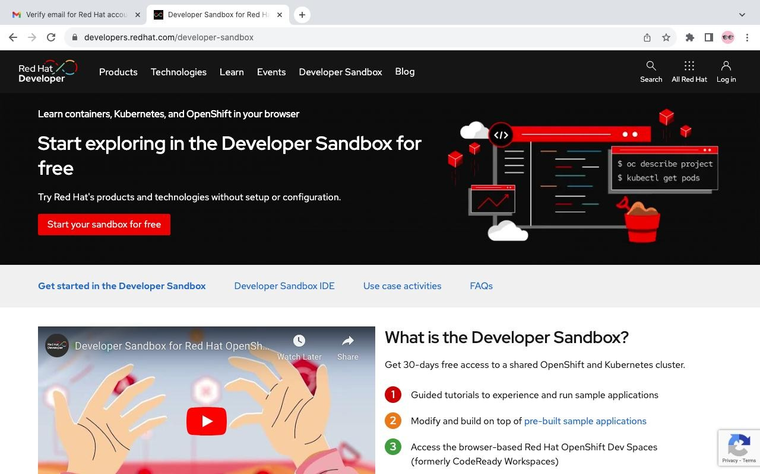

**Step 7: Click on DevSandbox and then login**

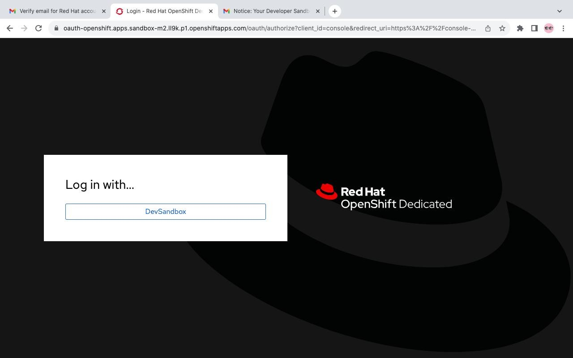

# Step 8: Click on DevSandbox and then login and fill the details

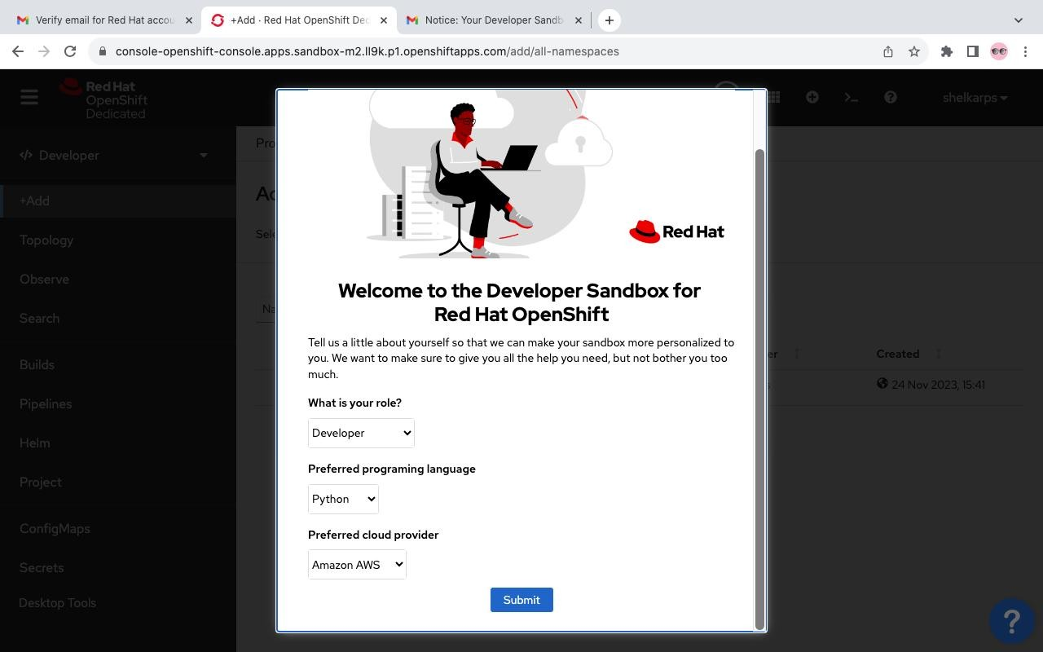

**Step 8: Click on + Add option at left side to create new project and then click Import from git**

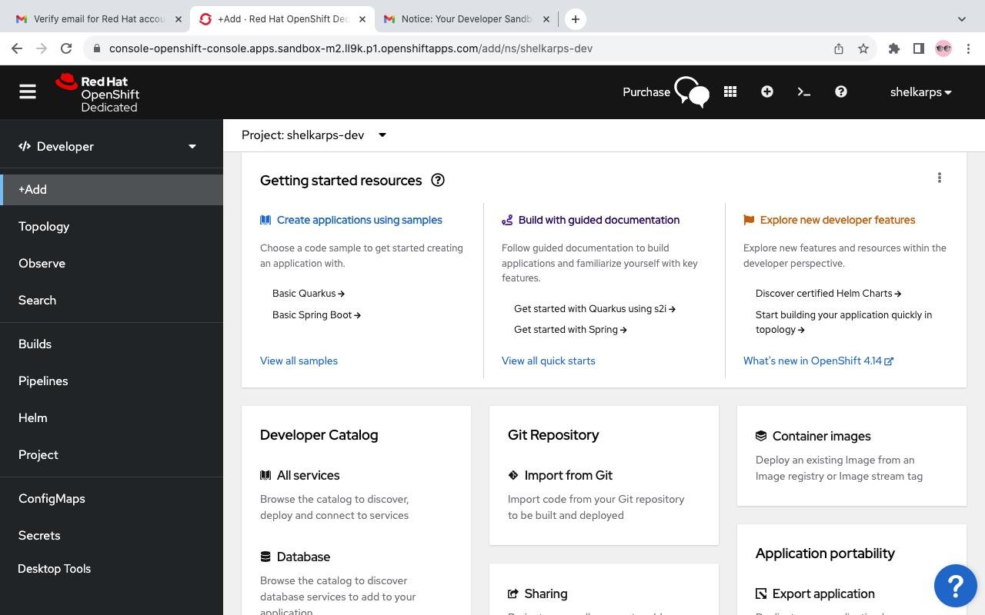

# Step 9 : Enter your public github repository link and select Builder Image as Import strategy and choose the builder image and then clikc create at bottom

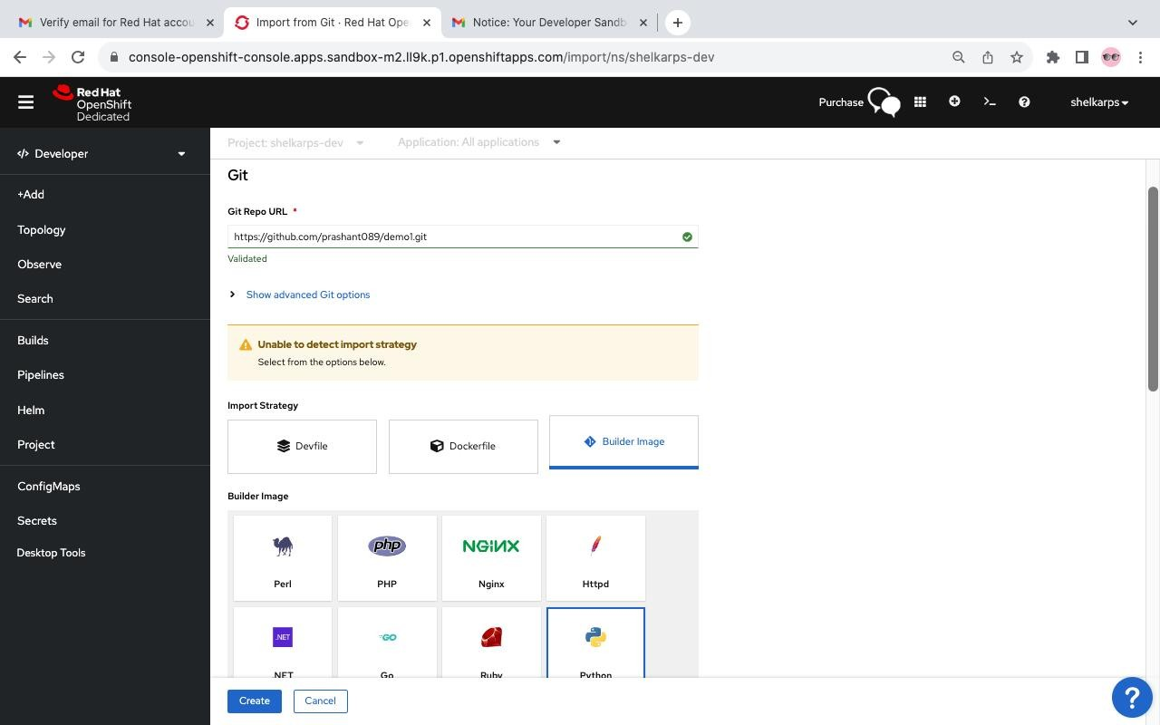

**Step 10 : Click on Toplogy at left corner and then click on build running**

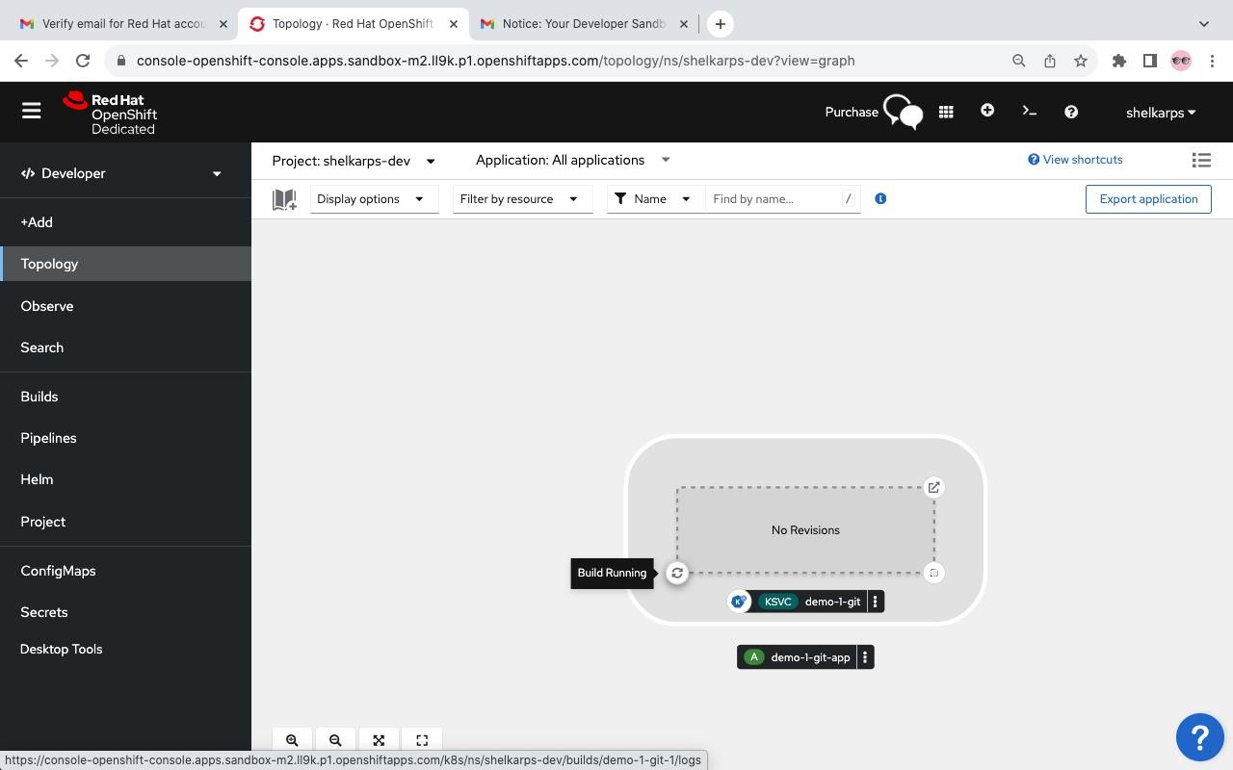

**Step 11 : Once the build running is successful you will see** Successfully pushed image

# then click again on topology and choose option at rigth corner edit source code

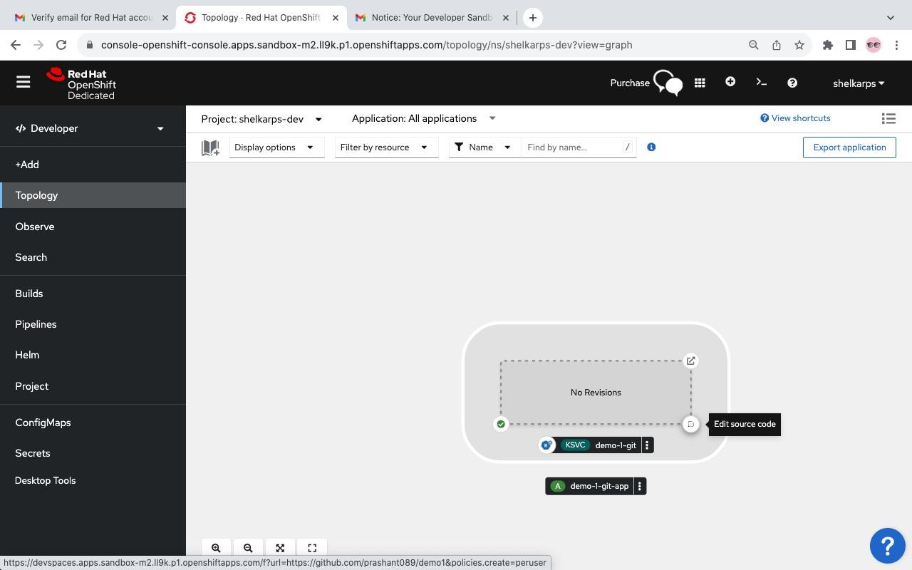

**Step 11 : Then click on Log in with OpenShift and then login with Devsandbox**

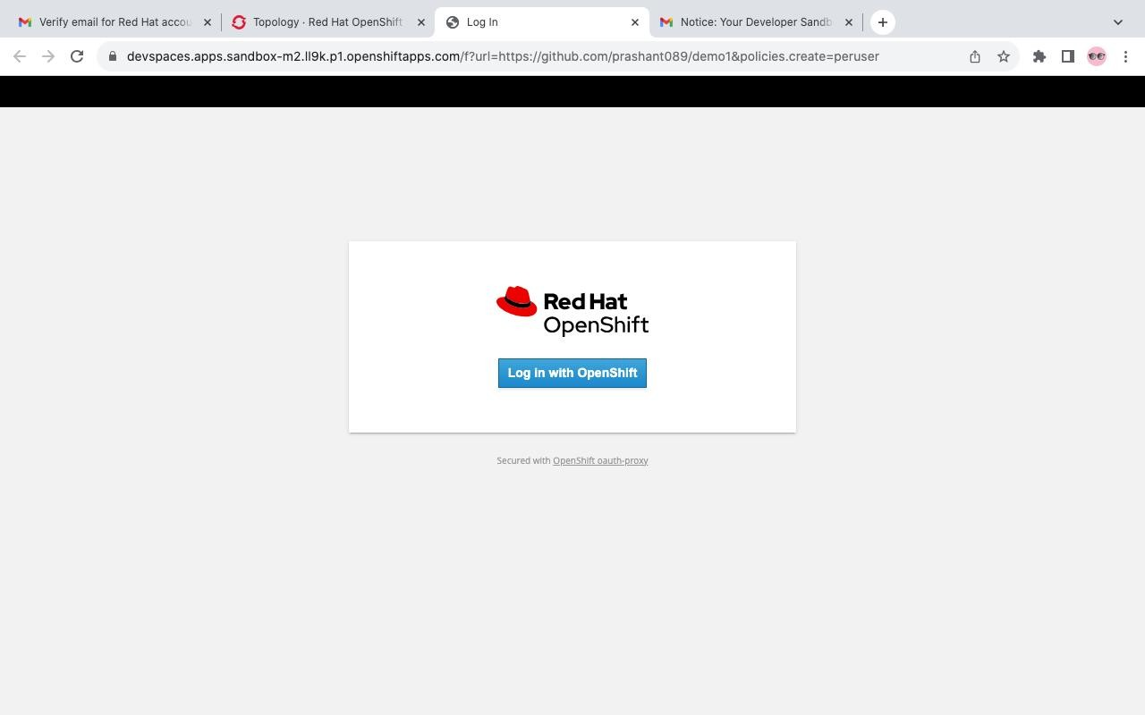

# Step 12 : It will take you to your workspace create there new file and save it and then right click on file name and choose Open in Integrated Terminal type command to run this file

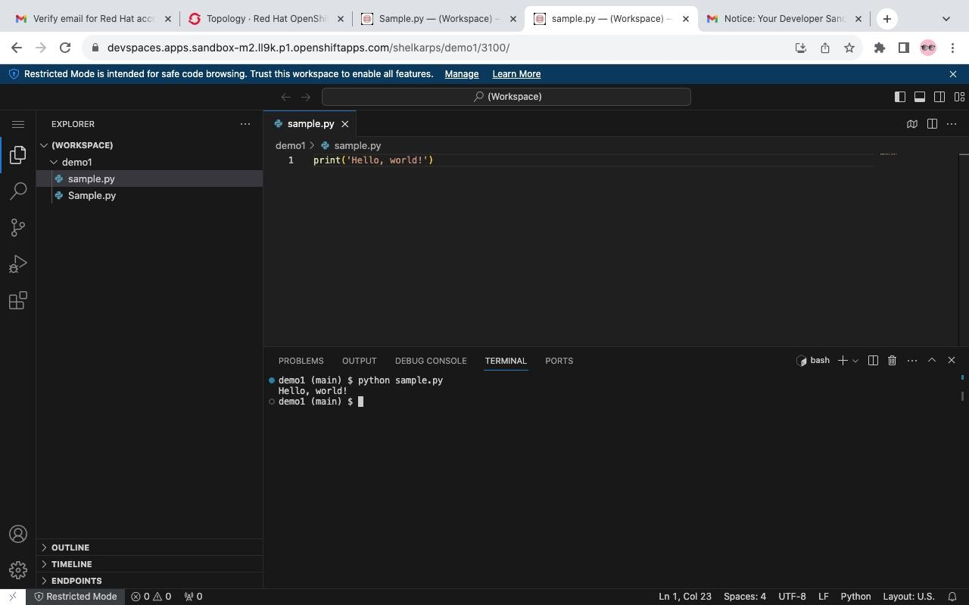

**Conclusion:**

Upon completion of this experiment, we have gained a practical understanding of how to work with Codenvy (now part of Red Hat OpenShift) to provision and scale a website. We have seen how cloud-based IDEs like Codenvy can simplify the development process, and how platforms like OpenShift can provide powerful tools for managing and scaling applications.